HDB Resale Price Statistical Report
ST3131
Emmanuel Ng Teng Yang | A0307702M

0. Introduction
Over 80% of Singapore’s population live in HDB flats, public housing stands as an important cornerstone of the social contract of Singapore and by proxy the resale market is of great importance. For many Singaporeans it represents one of the biggest investments they will ever make and for the government a key social issue that will affect their popularity. Hence the ability to predict the trends in HDB resale pricing is critical to all players in the housing market and this report aims to optimize the best possible linear model

For this task, we will transform the hdb-resale-July-2020 dataset and conduct some basic exploratory data analysis. We then use the transformed data to fit a base linear regression model to the data, conducting a model adequacy check to identify areas of improvement for our base model, after which using that to form a new model that we also run a model adequacy check on. We find that a model that incorporates a log transformation of the response and WLS with weights 1 over floor area applied is the best linear model for predicting HDB resale price.

1. Exploratory Data Analysis
Dataset Introduction and Data Transformation:
The hdb-resale-July-2020 dataset contains data concerning the selling price of 2456 HDB resale flats to some variables in July 2020. It includes resale price, which is the response variable, as well as the following features: month, town, flat type, flat model, block, street name, storey range, floor area (sqm), lease commencement date and remaining lease. We use the following transformations in table 1 to make the dataset more suitable for modelling.
Final variable | Source | Description | Type
Region | Block, Street Name, Town | All 3 source variables are related to how a location can affect HDB price. We map the current locations to market segments Core Central Region (CCR), Rest of Central Region (RCR), and Outside Central Region (OCR) as defined by URA to preserve the locationality significance. | Categorical
Months Left | Remaining Lease, Lease Commencement Date | Both source variables speak to how old the flat is, and since all flats are accounted for on the same date the number of months left is an accurate representation of the data. | Numeric
Lowest Floor | Storey Range | The source is a string, however with no overlap in storey ranges the useful data lies in its ability to tell us how high the flat is within the HDB and thus a lowest floor is sufficient numeric conversion. | Numeric
Flat model groups | Flat model | We summaries flat models into a few groups: standard (Model A, Improved, New Generation, Simplified, Standard), apartment (Apartment), premium (Premium Apartment, Premium Apartment Loft), maisonette (Maisonette, Model A-Maisonette), dbss (DBSS) and others (Model A2, Adjoined flat, Terrace, Type S1, Type S2, Multi Generation). | Categorical
Flat type | Flat type | Due to low number of multi-generation flats we combine Executive flats and multi-generation flats as executive flats are the most similar types of flats to multi-generation. | Categorical
Table 1: Data transformations
After all transformations we are left with the regressors flat type, floor area, region, lowest floor, months left and flat model groups with the response resale price.

Exploratory Data Analysis:
Analysis of response:
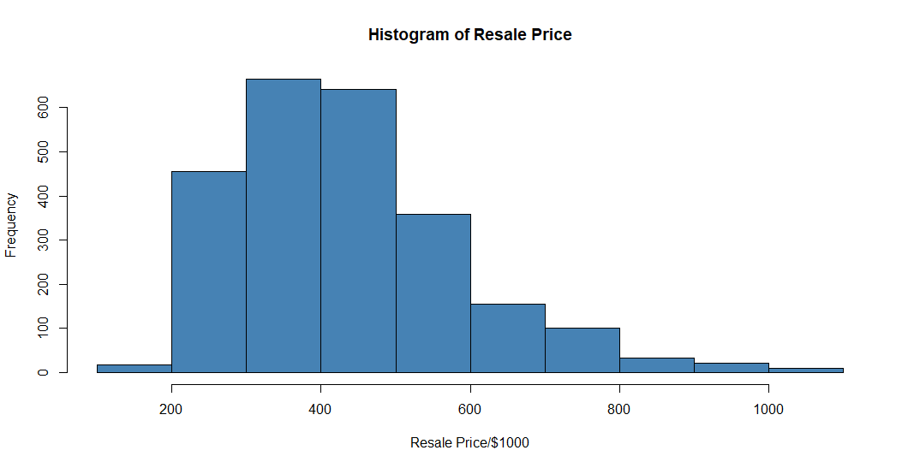
Figure 1: Histogram of Resale Price
From figure 1, we can see that resale price follows a unimodal right skewed distribution, which could indicate a violation of the normality assumption.

Analysis of Regressors:
We use a pairs plot to analysis the relationship between the response variable and various quantitative regressors. We use compute their correlation and plot a scatter plot between the various variables as seen in figure 2. We will use figure 2 for our analysis of the regressors. For categorical features, we plot boxplots of resale price against the categorical features as seen in figure 3.
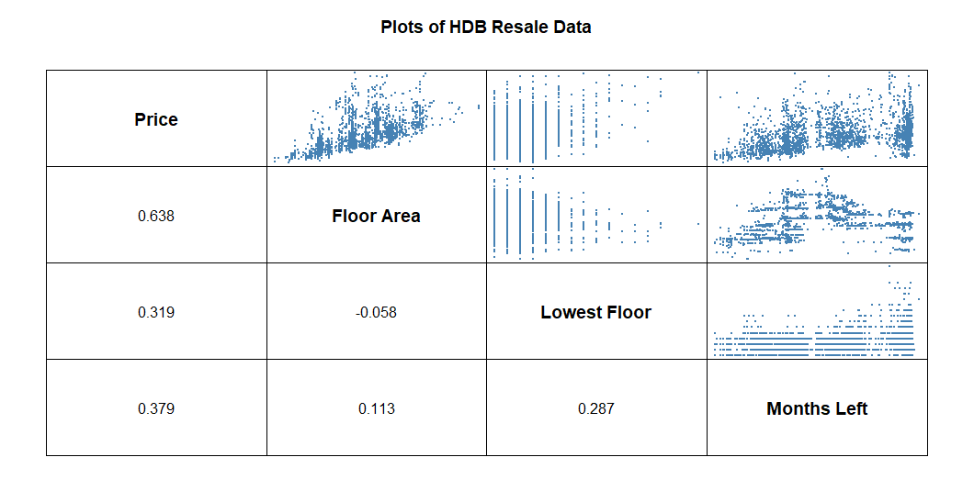
Figure 2: Pairs plot of HDB Quantitative Data
All 3 regressors have positive linear relationships with price, where floor area has a strong linear relationship and a correlation of 0.638, lowest floor and months left having weaker linear relationships with similar correlations of 0.319 and 0.379 respectively. Both floor area and months are relatively unstable relationships with price with variance increasing as the variable increases, while lowest floor has a relatively stable relationship with price with variance slightly decreasing as floor increases.
All pairwise scatterplots show no clear patterns, and correlation between regressors are low currently implying that linear dependence between variables is likely not present. To add on to the check done with the correlation matrix, we check for multicollinearity by computing the variance inflation factor (VIF) of each feature as well as the condition number of the correlation matrix. All features have a VIF of approximately 1 with none higher than 5, along with a conditioning number of 1.935, all checks indicate that multicollinearity is not a problem for M0.
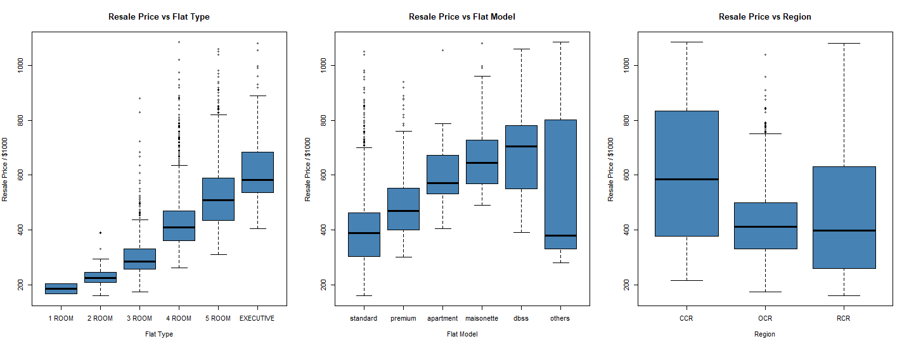
Figure 3: Boxplot of categorical features
For flat type, both the median and range of prices increases as number of rooms increase, each additional level having a median price almost equal to the 75th percentile price of the previous level. Flat model group similarly displays a trend where the median prices of flats are close to the 75th percentile of price of other flats, with the trend faltering after maisonette and violated by others which predictably has a large range. They also have relatively consistent ranges with the exception of dbss. Finally, as expected CCR has a much higher median price and price range than OCR and RCR, with RCR having a particularly small range as expected of its smaller sample size. Of note is the similarity between the trends in Flat model and type which might imply some relationship between them.

2. Model Building
Standard Linear Model (M0)
We first fit the base model M0 by including every feature as they currently are.
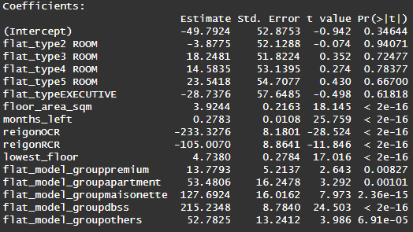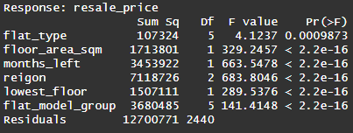
Figure 4: Coefficient table(left) and ANOVA table (right) of M0
M0 achieved an R-squared value of 0.7772, an adjusted R-squared value of 0.7758. Every feature under anova achieved a p-value less than 0.05 implying significance. However, flat type's p-value was much larger than the rest, further suggesting its effect may be partially captured by other correlated predictors such as flat model and floor area.

Model Adequacy Checking
We use M0’s studentized residuals (SR0),plot a QQ plot as well as plotting it against fitted values and the quantitative regressors to check its adequacy.
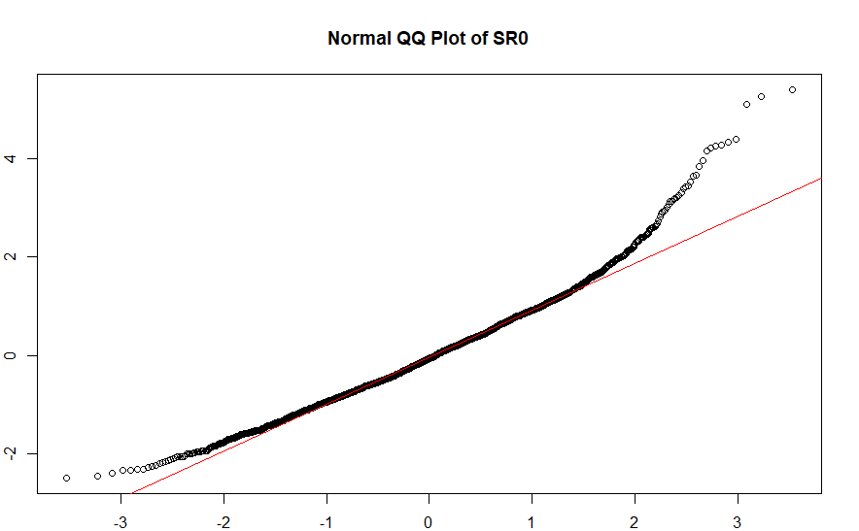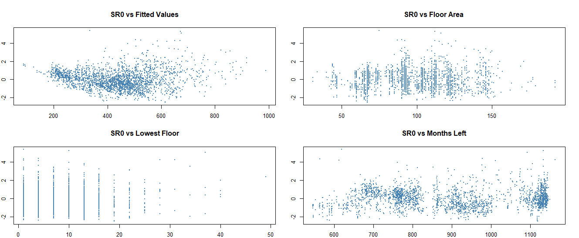
Figure 5: QQ plot of SR0 (Left) and SR0 residual plots (Right)
From the QQ plot we observe SR0 has a heavy left and right tail, with left tail more negative than normal and right tail much more positive than expected. suggesting a violation of the normality assumption. From the residual plots the SR0 vs months left and lowest floor are random with no significant trend. SR0 vs fitted values shows a double-bow indicating that variance of errors is not constant, while SR0 vs floor area has a slight cone shape pattern indicating heterogeneity.

Model Selection Process
As M0 exhibited non-normality in the QQ plot and a double bow pattern in the residual plot suggesting non-linearity, the Box-Cox method was applied to analytically select an appropriate transformation on the response. Given the resulting λ ≈ -0.3, we attempt the 2 closest lambdas since they are easier to interpret of -0.5 and 0 to build 2 linear models. Additionally, as SR0 vs floor area showed a cone shape pattern indicating heteroscedasticity increasing with floor area, WLS with weights 1 over floor area is applied. We thus first fit 3 models, log transformation (M1), reciprocal square root of response (M2) and WLS(M3) finding all useful, then fit 2 more models M4 and M5 as models with M1 and M2 response transformations respectively but with the WLS modification applied
Final model
After analysis, M4 (log(response) + WLS) is overall a better model and thus will be shown for the remainder of the report when it comes to equations or other non-comparison fields
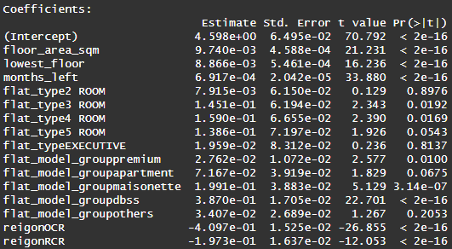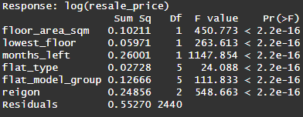
Figure 6: Coefficient table(left) and ANOVA table (right) of M4
M4 achieved an R-squared value of 0.8326, an adjusted R-squared value of 0.8315. Every feature under anova achieved a p-value less than 0.05 implying significance. A drop in flat type’s p-value implies it is now much more significant than compared to in M0.
Model Adequacy Checking
We use M4’s studentized residuals (SR4) and M5’s studentized residuals (SR5) to plot a QQ plot as well as plotting it against fitted values and the quantitative regressors to check their adequacy.
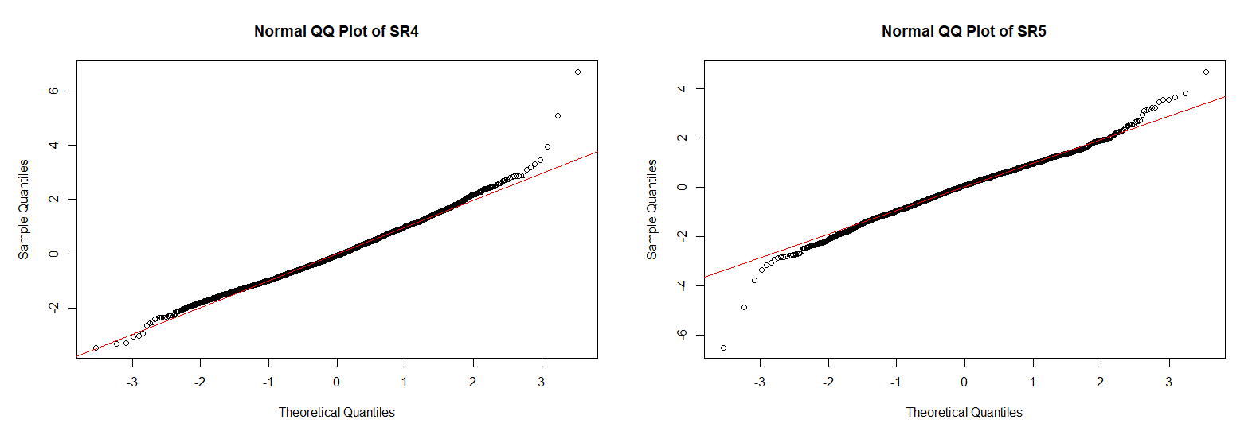
Figure 7: QQ plot of SR4 (Left) and SR5(Right)
Both QQ plots are much closer to normal than the base M0 model, with SR4 having some outliers on the right and SR5 on the left. However, the main difference comes in the residual plots
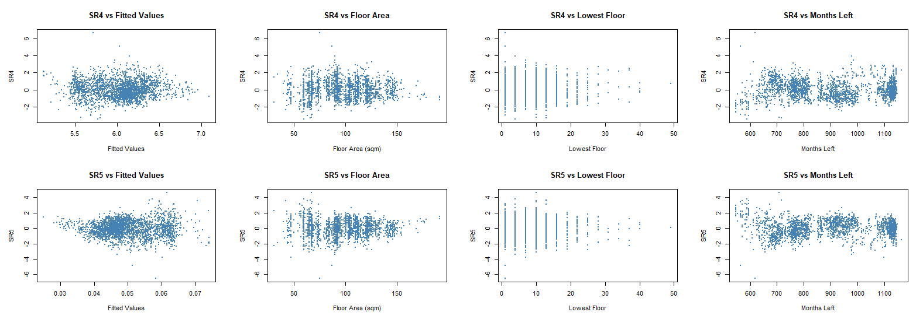
Figure 8: Residual plots of SR4 (Left) and SR5(Right)
In the residuals it is clear that while SR4 against fitted values and floor area no longer show any obvious non-linear patterns, SR5 vs fitted values clearly shows a cone pattern, hence making M4 the better model. Therefore, M4 is an adequate model, and the chosen improvement over M0.
Final Model and Interpretations
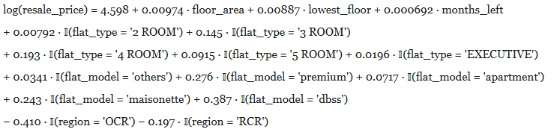
Equation of resale price and final equation
Base on the final model, holding all other factors constant, a 1 square meter increase in floor area results in resale price increasing by a factor of 1. 00978.Similarly holding all other factors constant, a CCR HDB flat has a 1.507 times higher resale price than an OCR flat, keeping all other factors constant. Both outcomes line up with our expectations for resale price.

Conclusions
Other than improvements in both adjusted R-squared and residual graphs, M4 is much easier to interpret than M5 or other principal component regressions and box-cox transformations. However, time is a key factor within the housing market and without a temporal outlook the model lacks much of the nuance of the rises and falls of the housing market. While a useful way to understand what Singaporean’s value in housing during July of 2020 additional data across a wider spread of time, as well as adjustments to make this model compatible with time series modelling would make this model significantly more useful as a general predictor of HDB resale pricing, allowing for the model to also capture seasonal trends in pricing.

